1. **BIT SUBTRACTION**

**EXP NO: 2**

**AIM:** To write an assembly language program to implement 8-bit subtraction using 8085 processor.

**ALGORITHM:**

1. Start the program by loading the first data into the accumulator.
2. Move the data to a register.
3. Get the second data and load it into the accumulator.
4. Subtract the two register contents.
5. Check for borrow.
6. Store the difference and borrow in the memory location.
7. Halt.

# PROGRAM:

LDA 8000 MOV B, A LDA 8001 SUB B STA 8002

RST 1

# INPUT:

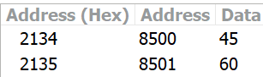

**OUTPUT:**

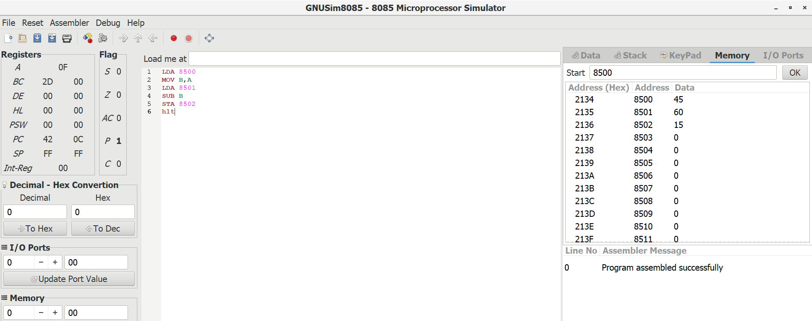

**RESULT:** Thus the program was executed successfully using 8085 processor simulator.